**1: Audit an existing App for Universal Design conformance**

I decided to concentrate on and analyse the Amazon app for this assignment. Both iOS and Android devices support this application. This program, in my opinion, is a wonderful example of how technology is applied and modified to be user-friendly and accessible.

The seven universal design principles are:

1. Equitable Use
2. Flexibility in Use
3. Simple and Intuitive Use
4. Perceptible Information
5. Tolerance for Error
6. Low Physical Effort
7. Size and Space for Approach and Use

I will examine how Amazon complies with each of the design principles in detail for the sake of this analysis.

1. Equitable Use

Equitable use refers to the design being useful and marketable to people with diverse abilities [1]. It is clear that the Amazon app is made to be utilized by people of all abilities. Users with disabilities can maintain their accessible choices across numerous devices with the use of Amazon's device synchronization feature, which also makes it possible for users to access the same information and data across multiple devices. The application provides text-to-speech and voice search in addition to synchronization. This is beneficial for those who want audio feedback [2].

1. Flexibility in Use

This principle refers to the design accommodating a wide range of individual preferences and abilities [1]. The user has the option to modify the interface, as can be seen by browsing the application. The user's ability to select a language can help make it easier for the user to read and navigate through the app, which is a nice example to demonstrate this. Also, the user is given a variety of payment options as they navigate the program to make a purchase. Credit or debit cards, Amazon Pay, and other digital wallets are included in this. This meets the needs of all users [3].

1. Simple and Intuitive Use

This principle states that the use of the design is easy to understand, regardless of the user’s experience, knowledge, language skills or current concentration level [1]. Examples of this are the readily available, obvious search tool and the product recommendations that assist consumers as they write their search query. This predictive feature demonstrates that the application is simple to use and intuitive for the majority of users.

1. Perceptible Information

Perceptible Information claims that the design communicates necessary information effectively to the user, regardless of ambient conditions or the user’s sensory abilities [1]. High-quality photographs of the product and multiple images of the same item that give the user a clear visual description of the product [4], are two examples of how amazon presents the user with clear information. The written product descriptions, user ratings and reviews for each item are another way that Amazon aids users in deciding whether or not to buy a product. Other elements that assist the user when using the application include the usage of icons and colour coding [5].

1. Tolerance for Error

The fifth principle of Universal Design discusses how the design minimizes hazards and the adverse consequences of accidental or unintended actions [1]. To help the user avoid making unintended purchases or to provide opportunity for error without being catastrophic, the application provides safety features. An illustration of this is when, prior to making a purchase, the program requests confirmation from the user and gives them a summary of their transaction [6]. Moreover, Amazon includes a "Buy Again" function that enables customers to buy any goods they have already purchased. This makes it possible to prevent users with cognitive impairments from purchasing the incorrect version of a product they are already satisfied with.

1. Low Physical Effort

This principle states that the design can be used efficiently and comfortably and with a minimum of fatigue [1]. Amazon offers people with physical disabilities a range of accessibility features such as large icons/buttons and voice search which help reduce the need for high physical effort from users with different capabilities [5] [7]. Amazon also offers the option to upload video reviews for users who have difficulty typing [7].

1. Size and Space for Approach and Use

Appropriate size and space is provided for approach, reach, manipulation, and use, regardless of the user’s body size, posture, or mobility [1]. The application improves the user's experience through the usage of large text and buttons. In order to give the user more options, the software is also made to run on a variety of devices with varied sizes and resolutions, including smartphones, laptops, and tablets [8].

The Amazon application conveys the principles of universal design excellently. All seven principles are satisfised, making it the perfect user-friendly and accessible online shopping app for everyone to enjoy. Its compatibility with assistive technologies, intuitive interface, and lenient attitude towards user errors make it an ideal choice for online shoppers. Additionally, the app conforms well to the principles of Universal Design with various features that cater to people with diverse abilities such as voice search options and a customizable interface that makes it easy to use.

Below I will include screen shots from the Amazon application that will convey how the app meets the seven principles of Universal Design.

**Voice recognition**

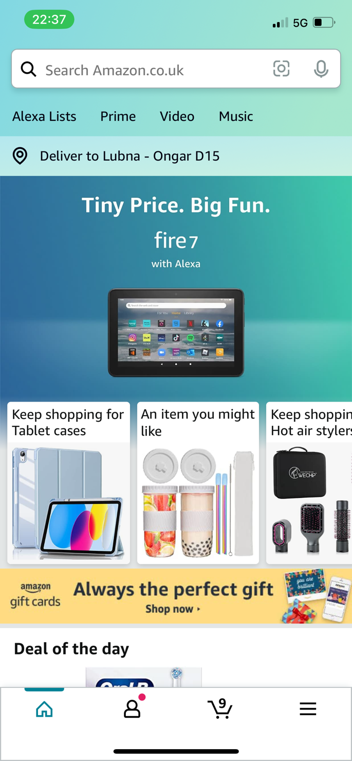

**Customizable Settings**

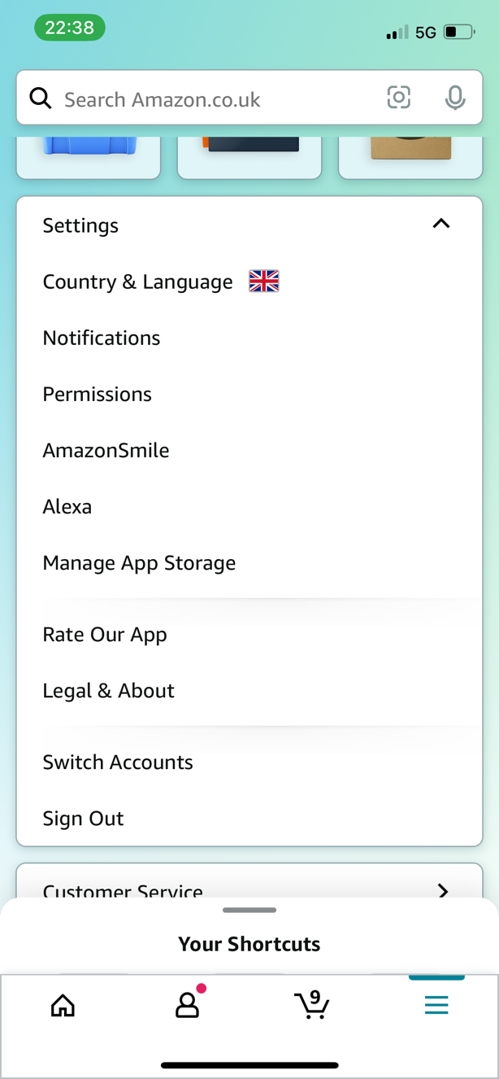

**Device Synchronization option**

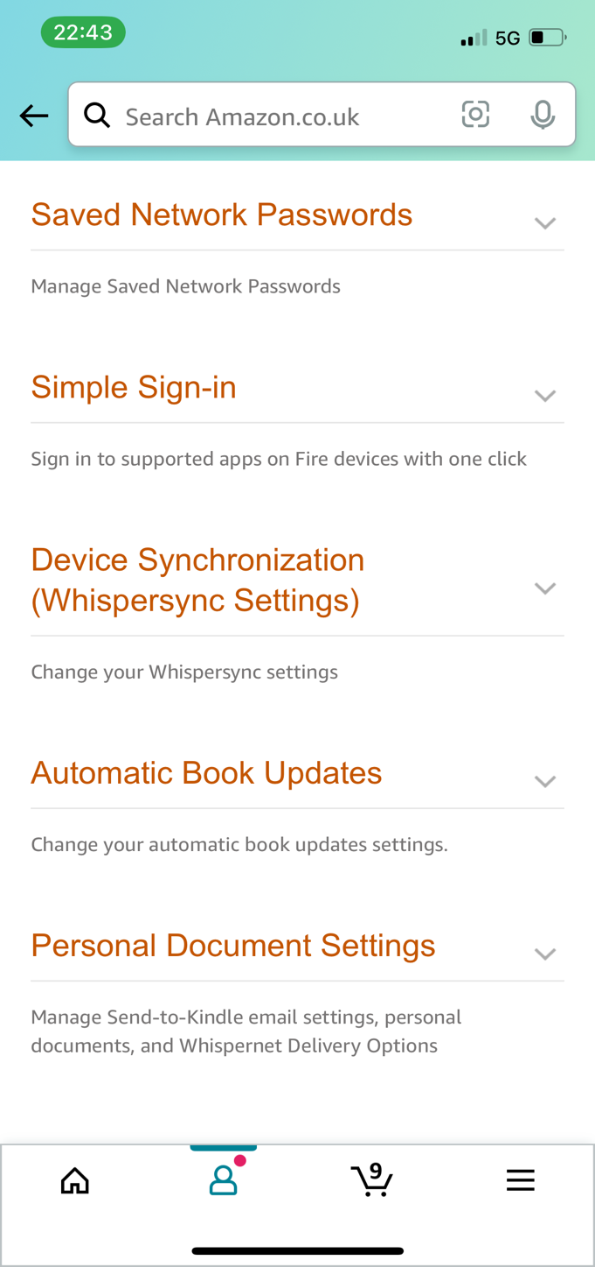

**Multiple images of the product**

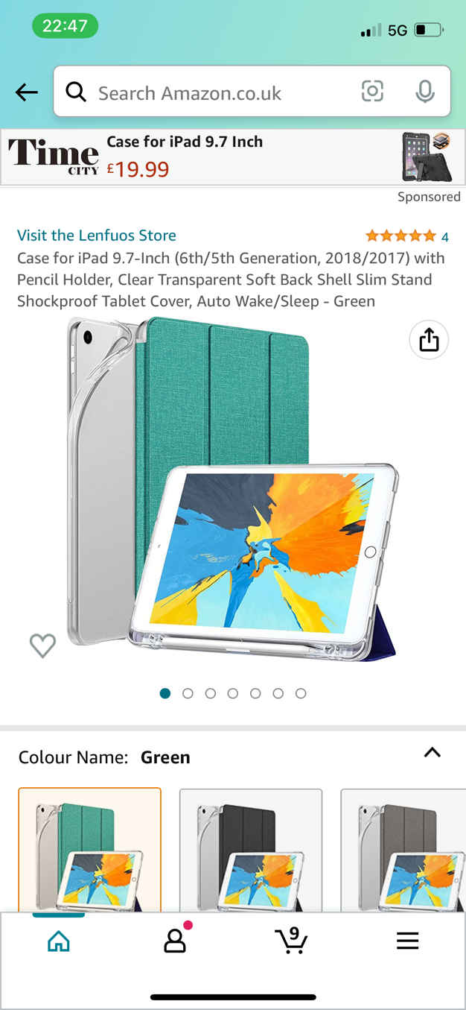

**Product Suggestions**

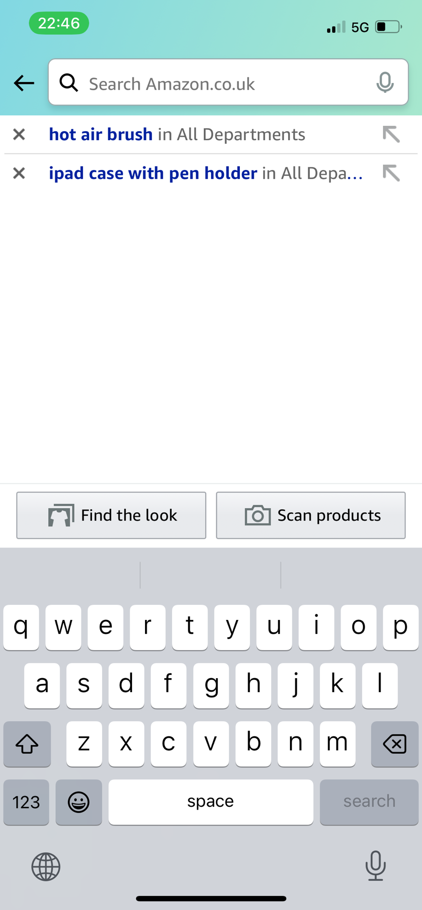

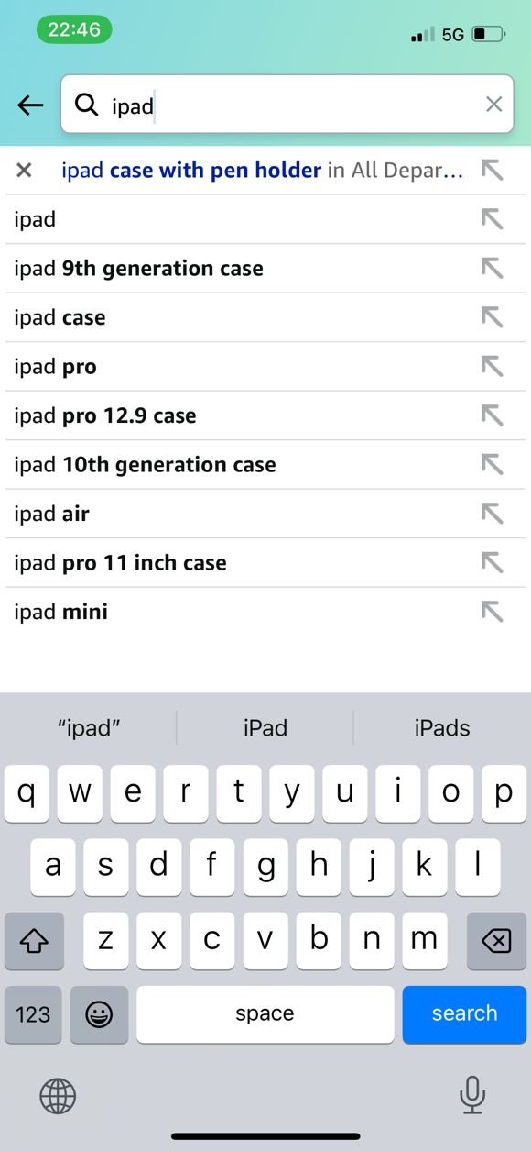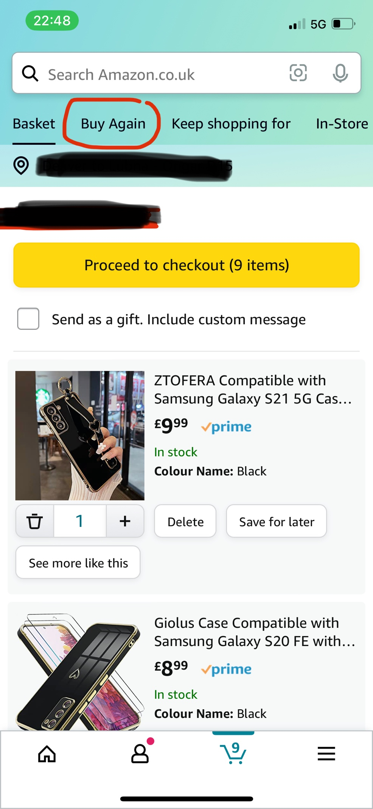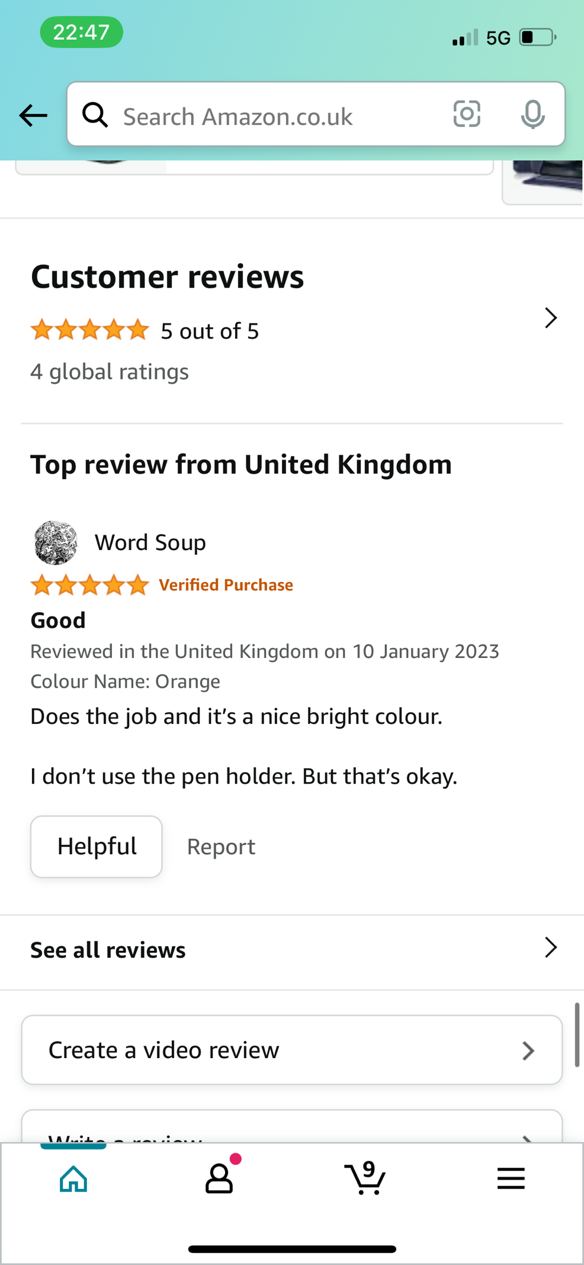

**Video review option**

**Buy again option**

**Product Suggestions and keyboard input**



**Reviews**

**Error Message**

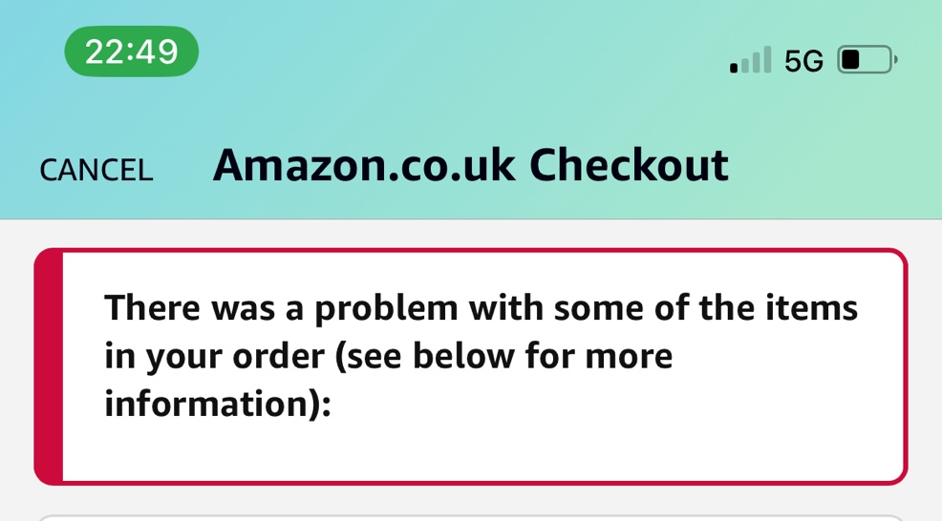

**2: Present an enhanced UD design of your chosen App (and wireframes)**

I’ve decided to design a subscription online shopping app, called “Ubox” that allows users to receive a box of curated items each month. Customers can select from a variety of categories, such as beauty, fashion, or technology, and then get a box of goods that are specifically curated to suit their tastes. The user's buying experience is intended to be simple, effective, and available to everyone. To ensure accessibility, Ubox is designed to be made available on a variety of devices with various sizes and resolutions, including smartphones, tablets, and PCs, as well as other key features which will make Ubox user-friendly.

The program will adhere to accessibility requirements including the Web Content Accessibility Guidelines (WCAG) 2.1, which can help guarantee that individuals with impairments can access the program. Below, I will be explaining the key design features that meet the seven principles of Universal Design.

1. Equitable Use

This application has been created so that everyone, regardless of age, background, or ability, can use it. I made the choice to incorporate text-to-speech and voice recognition as features to make sure that Ubox is suitable for users of all skill levels [7]. Those who require assistance navigating the program can also access live chat support within the application [9]. Ubox will become more usable for people who find it challenging to utilize the software on their own due to this feature, making it appropriate for all users.

1. Flexibility in Use

Designing the application in a way that allows the user to interact with it in various ways is another way to accommodate users with a range of abilities. When using the app, the user can customize the font size, language, preference for dark or light mode and choose between a 1-month subscription box or 3-months which can be set by using radio buttons [2] [10] . The user also has the option of using speech, touch, or keyboard input to browse the application, depending on their preferences [7].

1. Simple and Intuitive Use

Ubox is an application that can be used without any prior training because it is easy to use and intuitive. The usage of simple iconography and understandable images of the products is prevalent [5] [4]. The writing of product descriptions will also be free of any jargon that would otherwise confuse the user [11]. Also, Ubox will display a one-time-only pop-up with a step-by-step guide outlining how to use each key feature as soon as you launch the application after installation.

1. Perceptible Information

Ubox has the capacity to exhibit the information in a variety of ways to make sure that it is successfully delivered and presented. Text-to-speech can be enabled by the user if they wish to do so [7]. The interface will use high contrast colours and fonts that are readable by users with visual impairments in order to improve the efficiency of the application [2].

1. Tolerance for Error

To reduce user error, Ubox is built with a variety of mistake-prevention design elements. To let the user know they've made a mistake that could have grave consequences, I'll include error messages. To prevent mishaps, the application will also have a feature that will need the user's confirmation before doing any actions, such as making a payment [6].

1. Low physical effort

To guarantee that using the app is as effortless as possible, it will be straightforward and simple to use. Together with speech recognition, which will reduce the need for the user to rely on their fingers, Ubox will be programmed with large buttons to assist people with poor motor control [12] [13]. Also, the application's text will be clear and readable, helping users of all abilities. Upon checkout, a customer can set up a subscription option. This helps users which may not be able to physically visit shops every month or so, or carry items.

1. Size and Space for Approach and Use

Ubox is designed with users of all sizes and abilities in mind, to give them a good user experience.  Large, evenly spaced buttons will be used across the layout to make it easier for users to browse the program [13]. To provide the user more options, the software is also designed to run on a variety of devices with various sizes and resolutions, including smartphones, desktops, and tablets [8]. Users with impairments can easily check out using the application's simple checkout process. This means that the app offers numerous payment choices and provides clear instructions to meet the various requirements that consumers have [3].

The inclusive and user-friendly online shopping platform, Ubox was created with efficiency and accessibility in mind. It perfectly complies with the seven Universal Design principles, making it a user-friendly program that can be modified to meet the demands of users with various backgrounds and skills. Ubox provides conveniency by allowing users to set up recurring orders for items they regularly use, such as toiletries/beauty products. This can be beneficial for users with disabilities who may have difficulty physically getting to stores or carrying heavy items.

Below, I will include wireframes of what the application will look like.

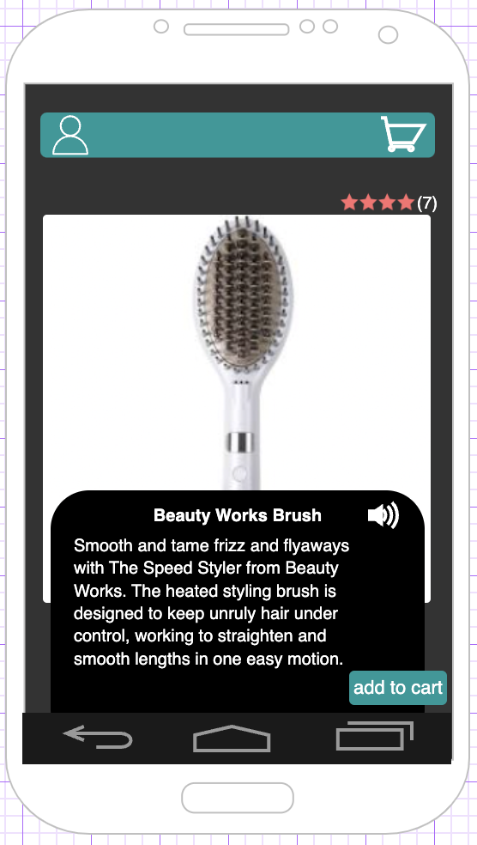

**Product page**

**Products page**

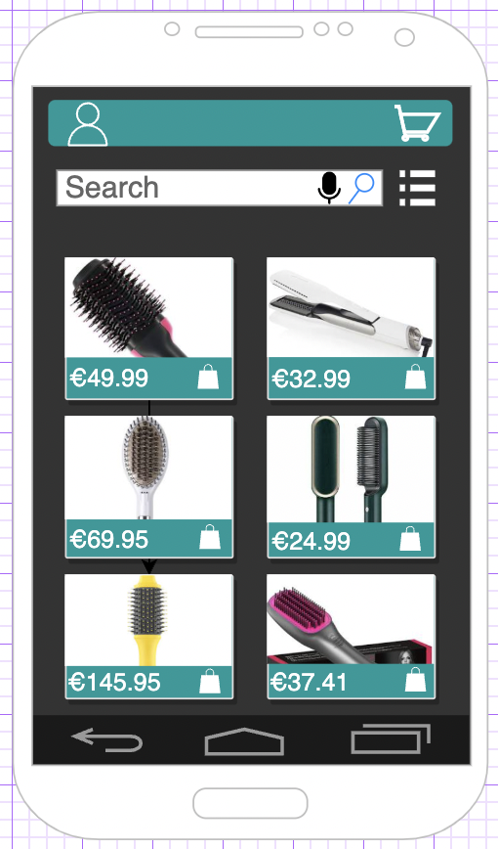





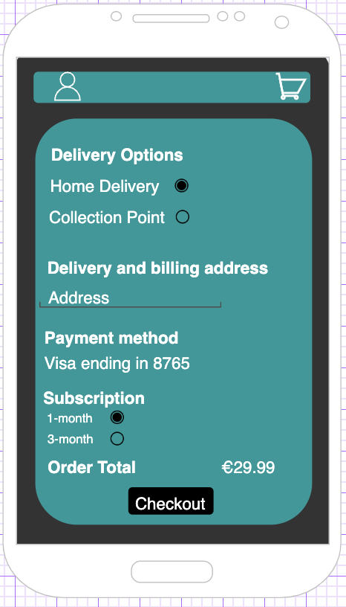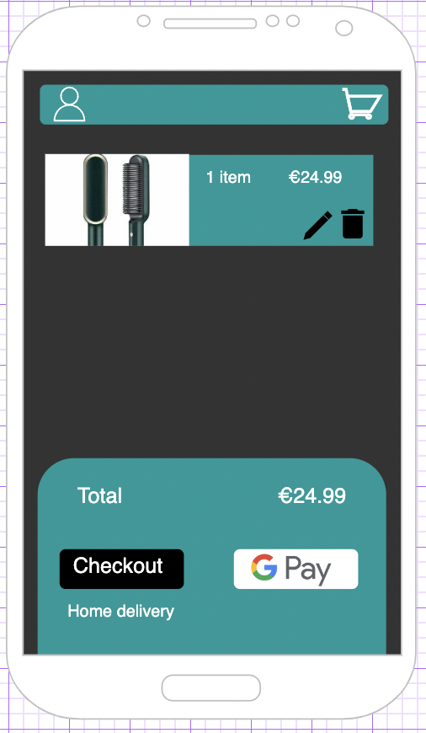

**Checkout page**

**Order page**

Checkout page

Shopping cart page

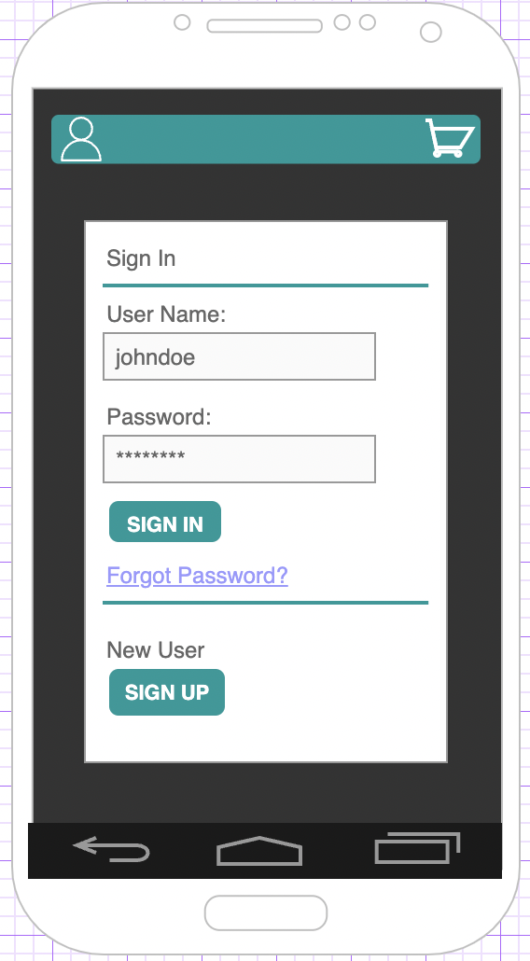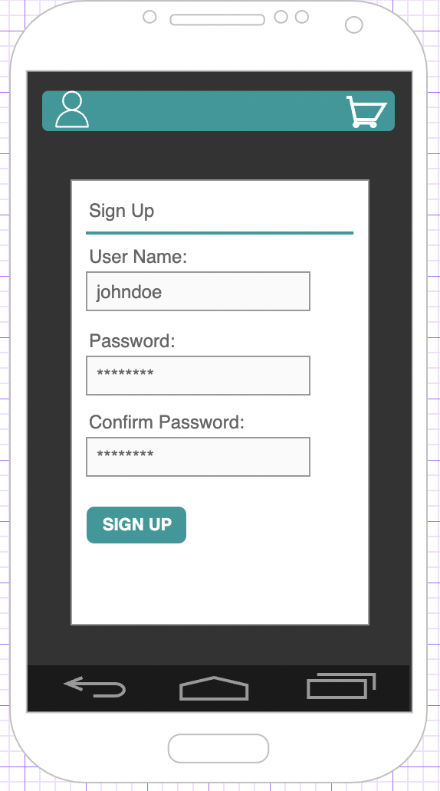

**Sign up page**

**Sign in page**





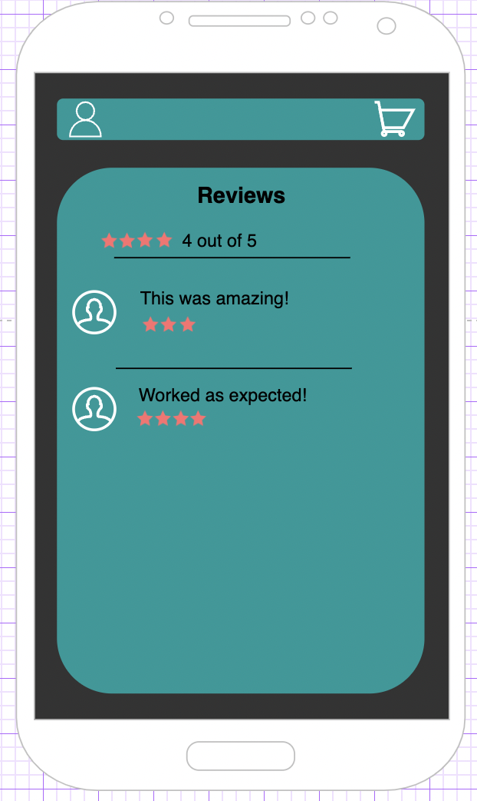

**Customer Service page**

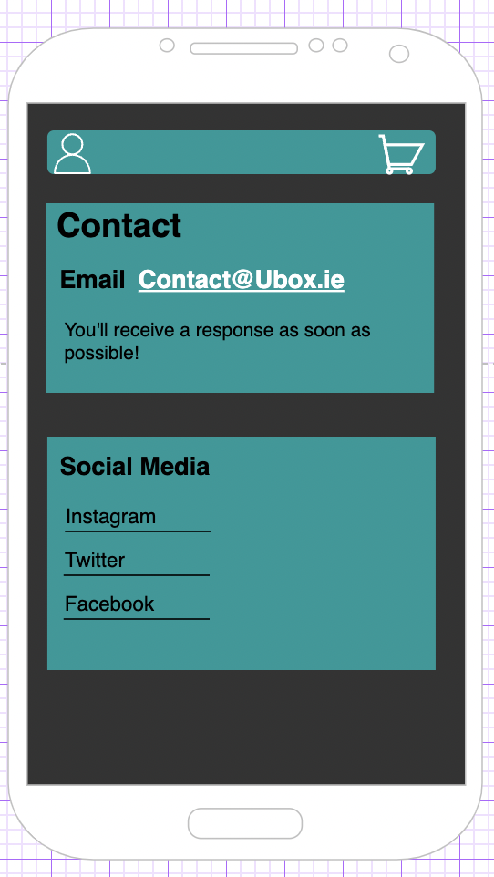

**Reviews page**

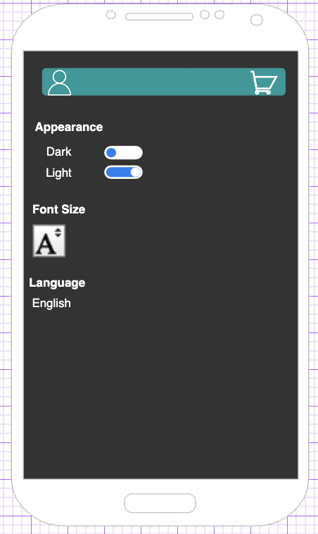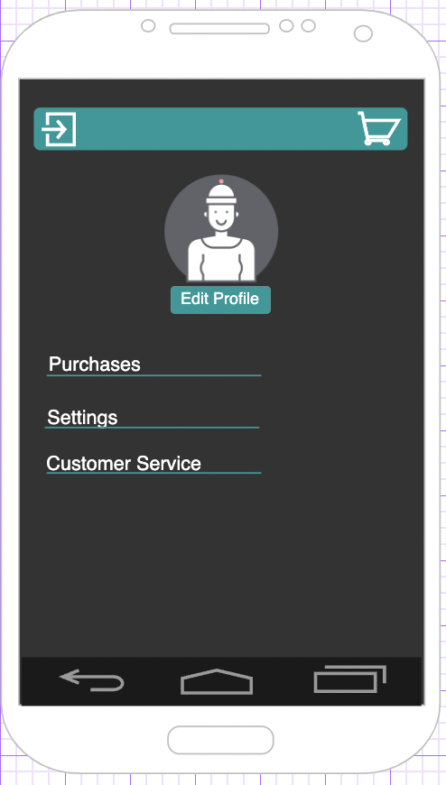

**Settings page**

**Profile page**



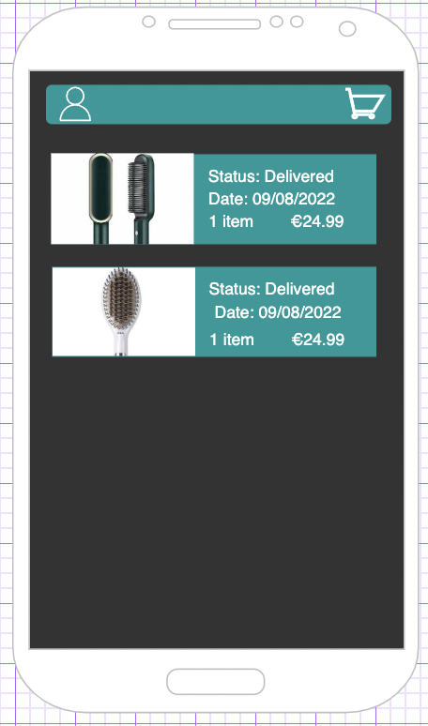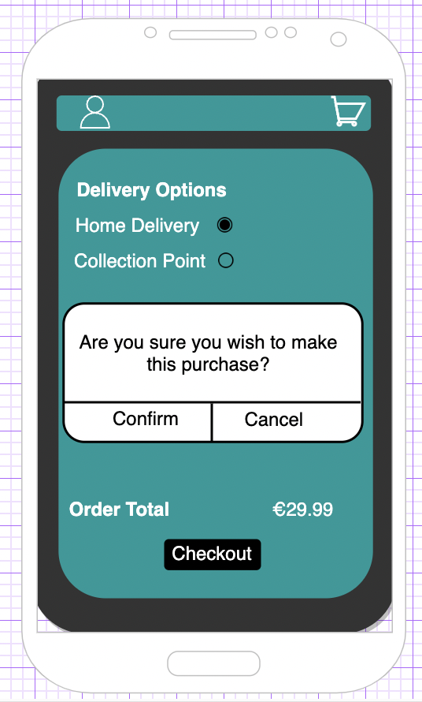



**Purchases page**

**Confirmation pop-up**

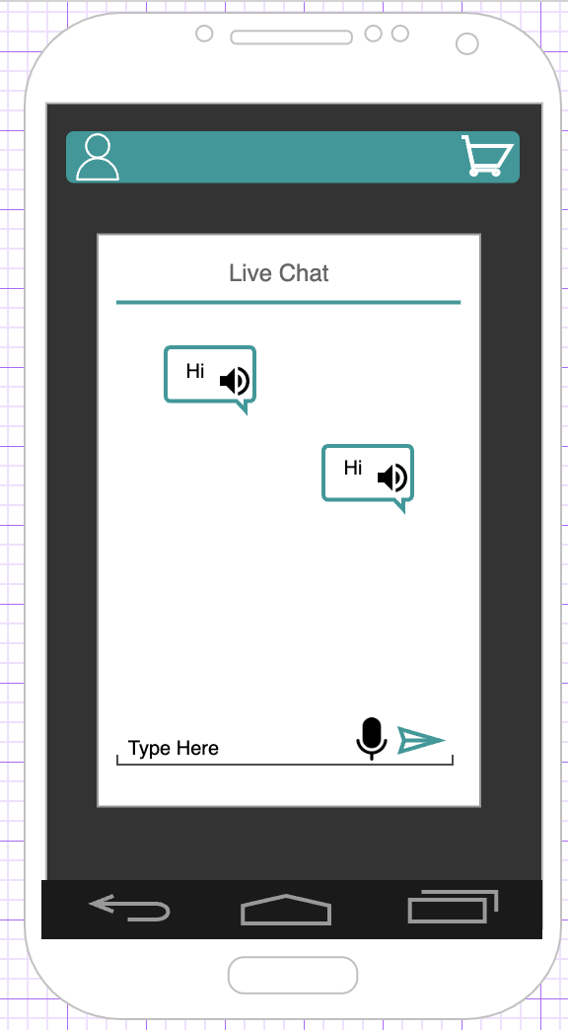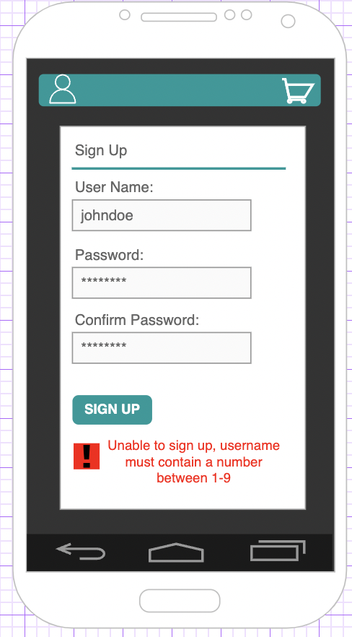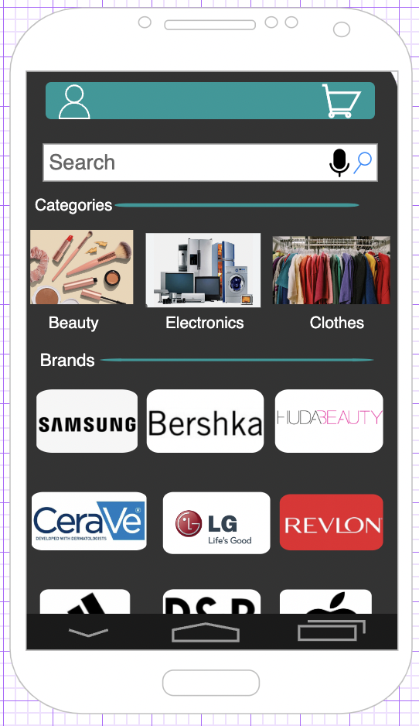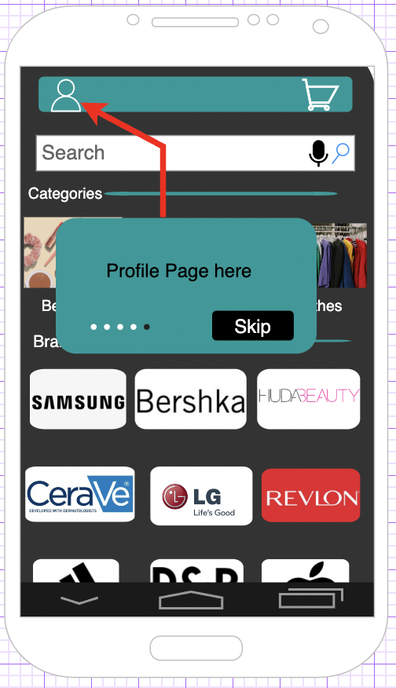

**Live Chat**

**Homepage**

**Pop-up Guide**

**Error message**

**3: Justify your Design Choices**

I think the design decisions I made above ensure that Ubox complies with the seven Universal Design principles. Any user can utilize this application, regardless of their age, ability, or background.

I made sure that everyone can use and access Ubox. I gave consideration to users with a variety of needs, skills, and backgrounds. This includes problems with motor control, reading, and typing. Ubox gives the user a variety of ways to engage with the application, including touch, keyboard input, and speech, ensuring that every user may access the software without difficulty [7].

I created Ubox to allow for flexibility after researching the many preferences and capabilities that users have. The user has the option to customize the application's colour, contrast, and font size to suit their preferences [2]. The application is user-friendly because it offers the user the choice of interacting with it by touch, voice, or keyboard input, giving them greater flexibility [7].

The design choices for Ubox also make this application simple and intuitive to use. Ubox does not require any prior training to be able to use the application. It has a clear and to-the-point interface meaning it is convenient for all users. The use of the help features such as the pop-up guides and live chat are a great addition that increases the accessibility [9]. Along with that, I have used language void of jargon, icons and images of the products that make it easier for the user to understand the information given [11] [4].

My application's design ensures that every user may understand the provided information clearly and without any difficulties. Ubox takes advantage of text-to-speech to ensure that this guideline is observed [17]. All users will be able to read and understand the content thanks to the use of large text and high contrast colours [2].

When using the app, the user will notice error-prevention features such as error messages. These messages will alert the user of a potential mistake they are about to perform [14]. Moreover, Ubox offers confirmation prompts that will request the user's approval before an action, such as making a purchase [6].

I considered users who want applications that require little physical effort when I was building Ubox. To minimize the demand for fine motor control, I chose to include large and well-spaced buttons and big text [13]. Also, the integration of speech recognition eliminates the necessity for keyboard input, reducing the physical strain on the user's fingers [12]. This application is an online subscription app. This means users who find it difficult to leave their house for products they use monthly or frequently or find it hard to carry items, can make use of Ubox. Users have a 1-month or 3-month subscription option.

Ubox effectively implements all seven Universal Design principles, enabling all users to enjoy the application. For customers to access and use the app with ease, Ubox offers a variety of adjustable settings, and user-friendly design features. Ubox is suitable for users of different backgrounds and skills, due to the various features that I have explained above. The software is also designed to work with devices of different sizes and resolutions, including smartphones, laptops, and tablets, to give all users a greater range of options.

***References:***

[1] “Universal Design – 7 Principles for Inclusion”, John Gilligan, <https://brightspace.tudublin.ie/d2l/le/content/237835/viewContent/1821920/View> , 05/02/2023

[2] “Dos and don’ts on designing for accessibility”, 02/11/2016, Karwai Pun, <https://accessibility.blog.gov.uk/2016/09/02/dos-and-donts-on-designing-for-accessibility/> , 05/02/2023

[3] “Are Online Payment Systems Accessibility Friendly?” , 23/11/2019, Cassie Warrington, <https://www.paymentsjournal.com/are-online-payment-systems-accessibility-friendly/> , 05/02/2023

[4] “Images Tutorial”, 08/02/2022 , Brian Elton , <https://www.w3.org/WAI/tutorials/images/#:~:text=Images%20and%20graphics%20make%20content,orient%20themselves%20in%20the%20content>. , 05/02/2023

[5] “Use Icons that Help the User”, 29/04/2021, <https://www.w3.org/WAI/WCAG2/supplemental/patterns/o1p07-icons-used/> , 05/02/2023

[6] “Mobile Accessibility: 10 Tips and Tricks to Make Your App More Accessible”, 21/07/2021, Rosa Heide, <https://intive.com/insights/mobile-accessibility-10-tips-and-tricks-to-make-your-app-more-accessible> , 05/02/2023

[7] “Tools and Techniques”, 15/05/2017, Shadi Abou Zahra, <https://www.w3.org/WAI/people-use-web/tools-techniques/> , 05/02/2023

# [8] “To Make Apps Accessible, Make Them Compatible with Different Devices” , 07/08/2019, Susanna Zaraysky, <https://medium.com/google-design/to-make-apps-accessible-make-them-compatible-with-different-devices-11298c6d3f06> , 05/02/2023

# [9] “Make It Easy to Find Help and Give Feedback”, 29/04/2021, <https://www.w3.org/WAI/WCAG2/supplemental/patterns/o7p05-findable-support/> , 07/02/2023

[10] “HOW TO MAKE YOUR APP MORE ACCESSIBLE” , 01/04/2022, Lily Mordaunt, <https://blog.usablenet.com/5-points-to-remember-to-make-your-app-more-accessible> , 07/02/2023

[11] “Understandable Content”, 23/01/2019, Shadi Abou Zahra, <https://www.w3.org/WAI/perspective-videos/understandable/> , 07/02/2023

# [12] “Speech Recognition” , 26/02/2021, Shadi Abou Zahra, <https://www.w3.org/WAI/perspective-videos/voice/> , 07/02/2023

# [13] “Large Links, Buttons, and Controls”, 23/01/2019, Shadi Abou Zahra, <https://www.w3.org/WAI/perspective-videos/controls/> , 07/02/2023

# [14] “User Notification”, 03/06/2022, Shadi Abou Zahra, <https://www.w3.org/WAI/tutorials/forms/notifications/> , 08/02/2023